**Guide How to Run Program**

1. Launch Client class 2 times for 2 users, 3 times for 3 users and so on (Pic 1).

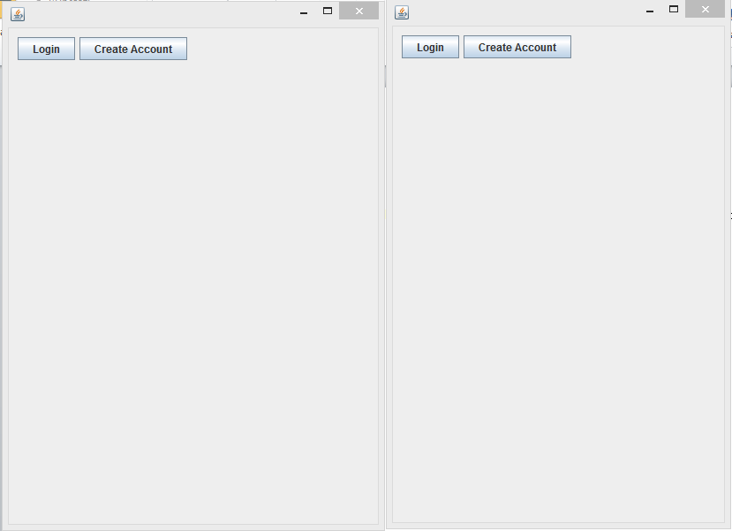

Pic 1

1. Login or create accounts (Pic 2)

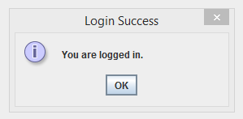

Pic 2

1. Notification that user was offline but now is online (Pic 3)

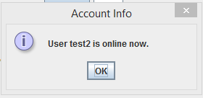

Pic 3

1. After login you can start chat, create new chat, start private chat or create a private chat with online users (Pic 4)

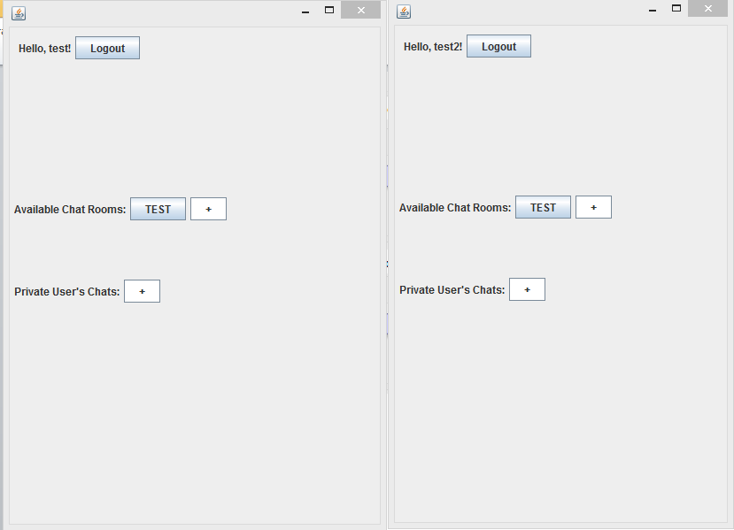

Pic 4

1. Choose available chat by clicking on it (Pic 5). Start chatting. In this screen TEST chat was created by test user that is why only test user can delete it (Pic 6).

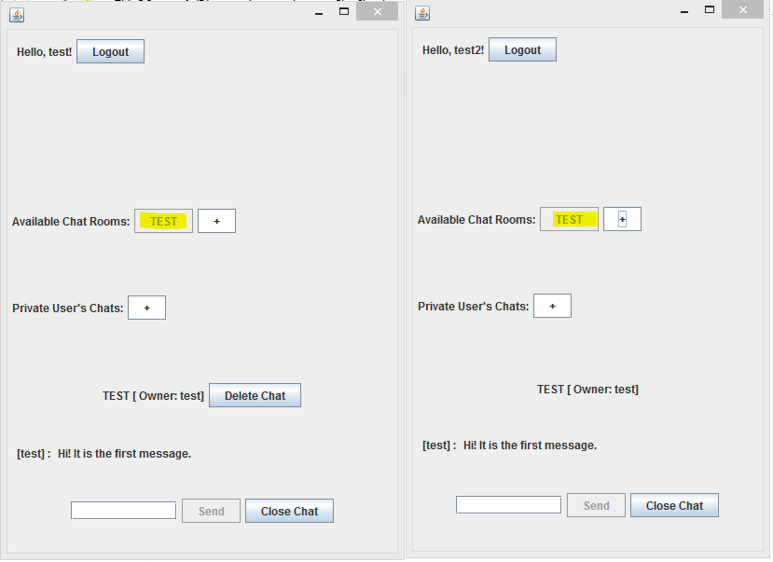  
 Pic 5

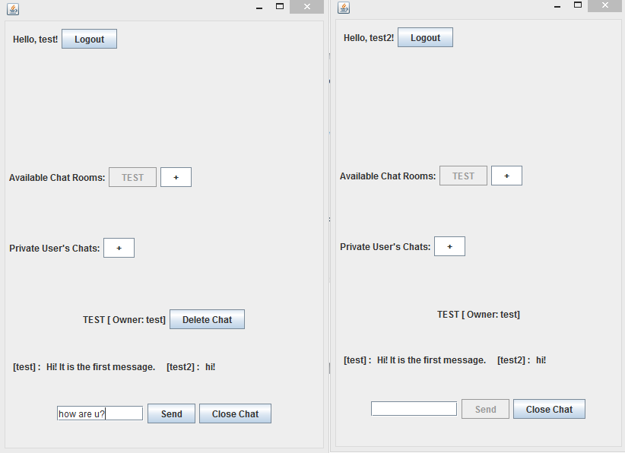

Pic 6

If test user delete the chat notification is shown or all users (Pic 7).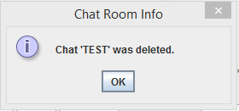

Pic 7

GUI after deleting chat (Pic 8).

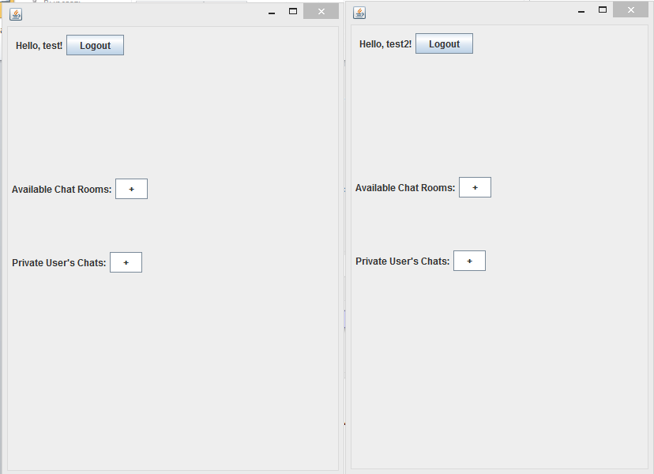

Pic 8

1. Click “+” to create new chat or private chat. Now test2 user is going to create private chat (Pic 9). There are all online users in the combo box. Choose one, click ok. Notification will be shown to owner and chosen companion from combo box (Pic 10).

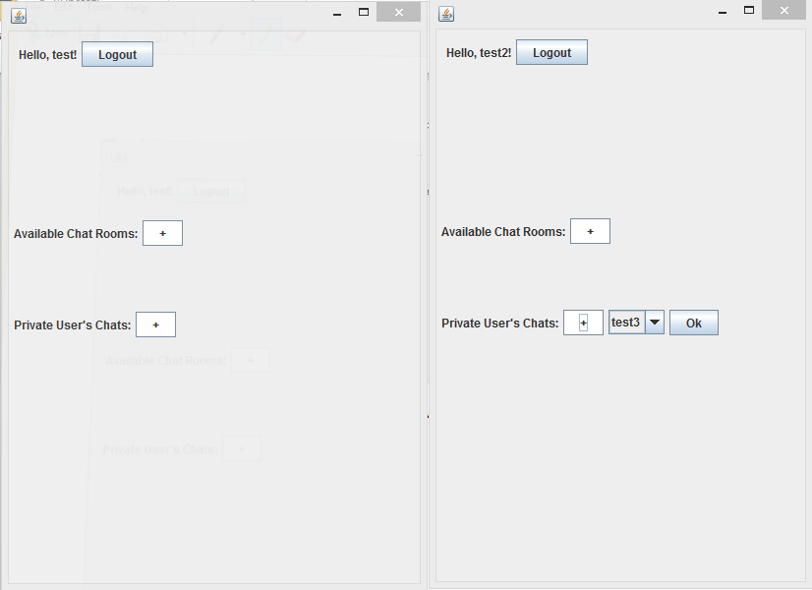

Pic 9

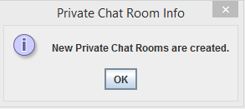

Pic 10

Private chat room between test2 and test3 users should not be shown for test user (Pic 11-12).

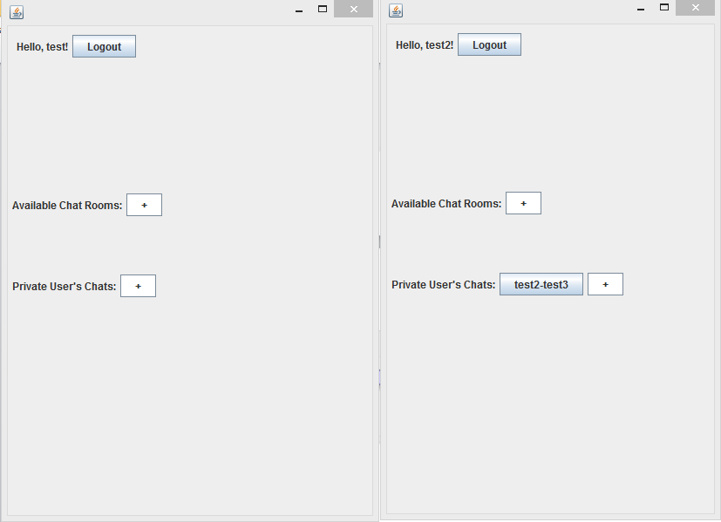

Pic 11

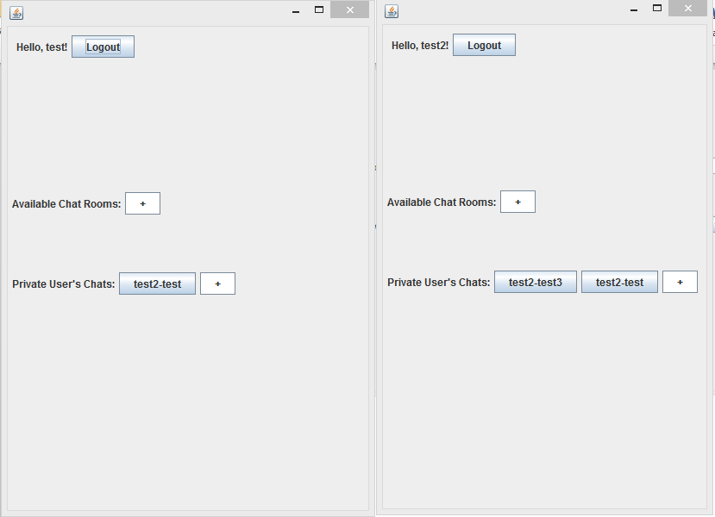

Pic 12

1. Open private chats and start communication (Pic 13).

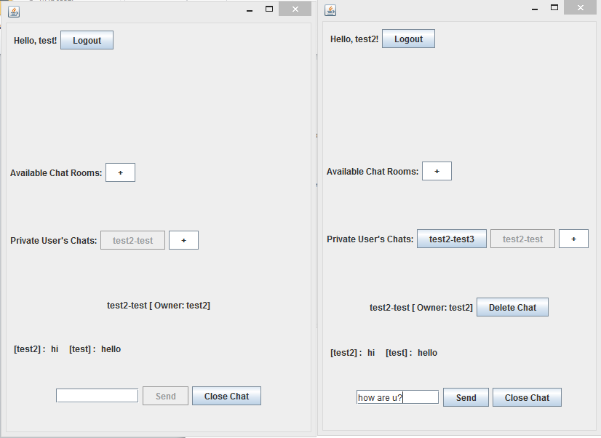

Pic 13

1. Logout to finish chat session (Pic 14). Other users will receive notification (Pic 15)

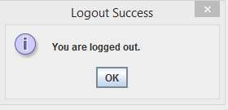

Pic 14

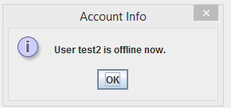

Pic 15